MSSQL Electric Vehicle Analysis
1) Total no of Electric Vehicles
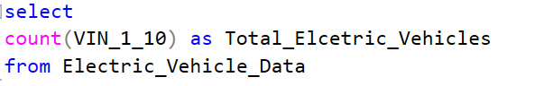
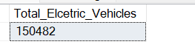
2) Average Range of Electric Vehicles 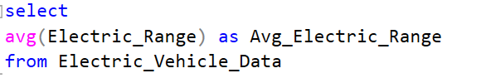
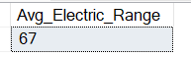
3) Total no of Electric Vehicle Types
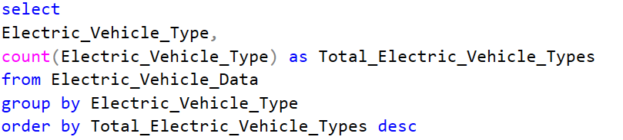
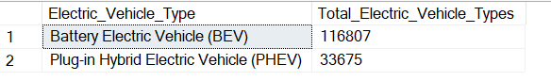
4) % of BEV Vehicles
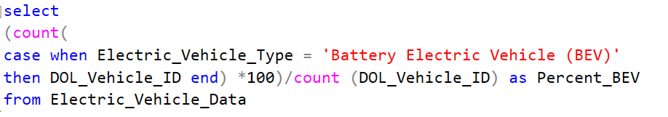
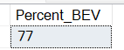
5) % of PHEV Vehicles
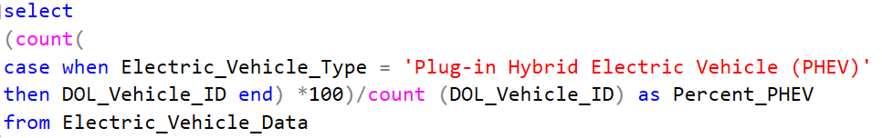
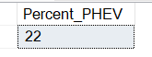
6) City wise total no of Electric Vehicles
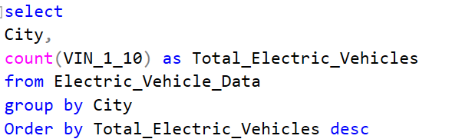
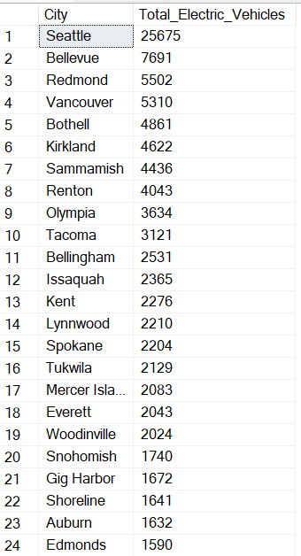
7) Electric Utility wise total no of Electric Vehicles
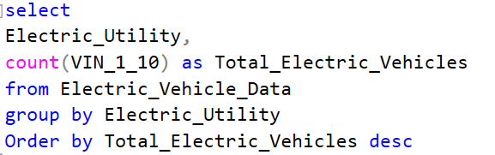
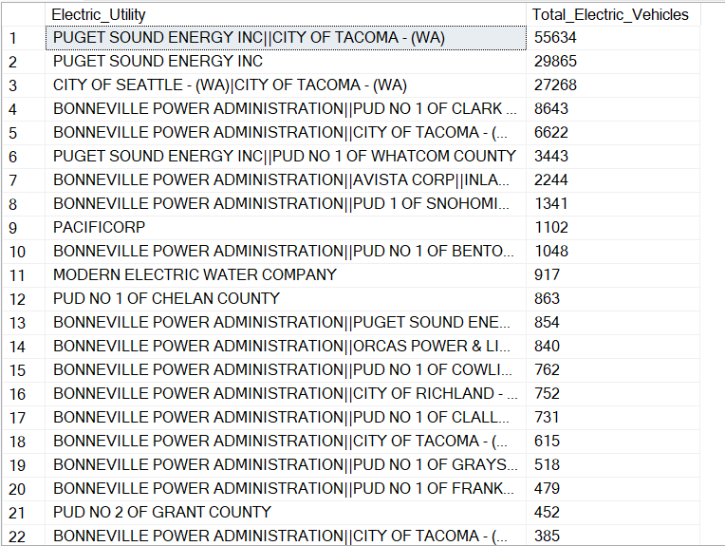
8) Total Vehicles by Model Year
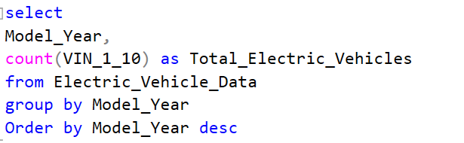
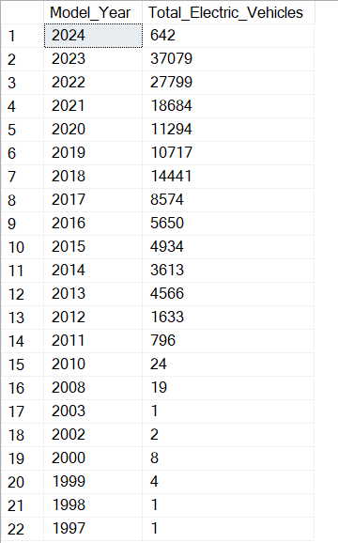
9) Total Vehicles by State
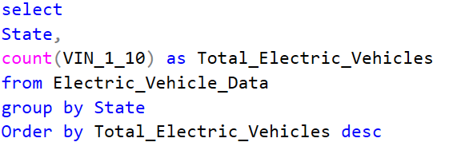
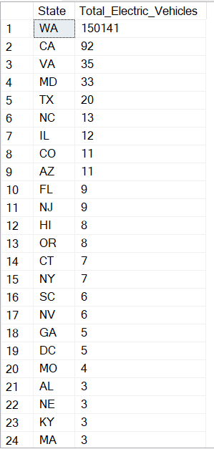
10) Total Vehicles by Make
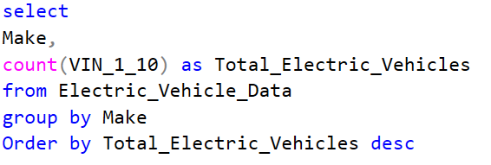
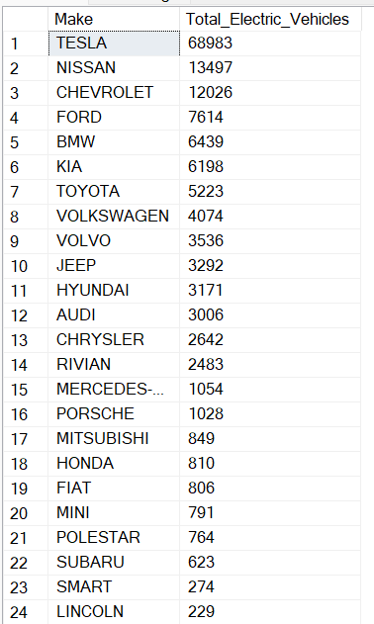
11) Total no of Vehicles by CAFV Eligibility
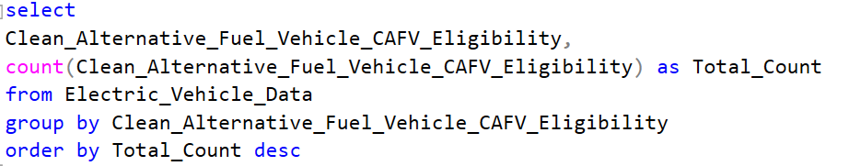
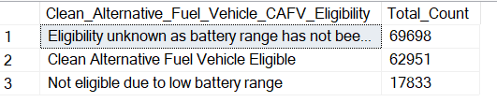
12) Percentage of Eligibility unknown
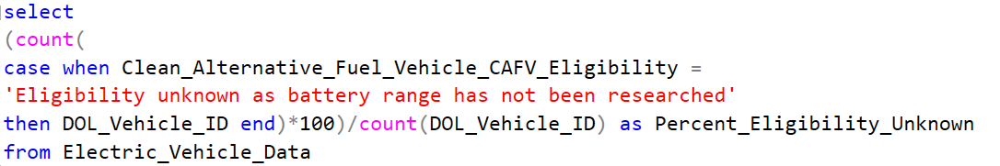
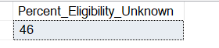
13) Percentage of CAFV Eligibility
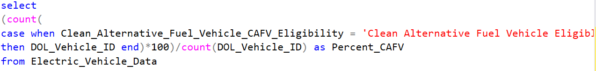
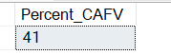
14) Percentage of Low Battery Range Vehicles
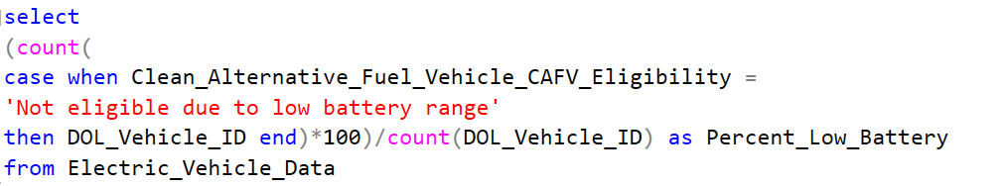
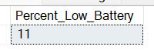
15) Total count of models by make, model and Year wise
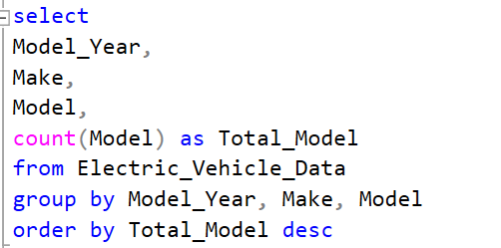
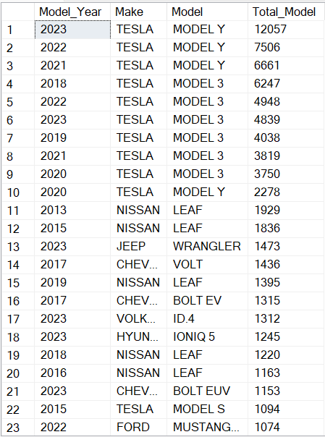
16) State and make wise total count of Model
